**CP3407** ASSESSMENT TASK 1: **Project part-1**

**Team Information**

Github: <https://github.com/myth002/CP3407_A1> (Private repository)

Website: <https://myth002.github.io/CP3407_A1/orders.html> (Public website)

**Team Members:**

Anumolu Sandeep Prasad (13156974)

Role: Team Leader

Udaya Bhaskar Reddy Malkannagari (13368171)

Role: Lead Designer

Fadni Harisyam (13269323)

Role: Lead Researcher

**Project Description (non-ICT)**

**Company Background**

K-Market PTE. LTD, is a wholesale trading business established in the year 2006 focusing on trading groceries to restaurants in Singapore.

The company was bought over by the current directors in 2012 to expand the ongoing trading business.

**Company’s Business Growth Plan**

Due to constrain in generating revenue solely from restaurants was a uphill task. The revenue from restaurant business was having a downtown in 2016 due to tough competition from new entrants to the business who were undercutting which causing price war among the existing trading companies.

Labour shortage contributed to the closing of many restaurants which made it difficult to collect our payment dues.

In 2017, we decided to shift our focus from the restaurant to providing groceries to established hotels as we saw growth in visitors from the Asian region. This noticeable growth of tourists consuming Asian food opened the opportunity to expand our business.

Being a certified Halal trader, we were able to penetrate various hotels in Singapore to offer dried Asian groceries.

**Project Title**

Development of *K-Market*wholesale application to increase productivity and revenue.

**Project Goal**

Implementation of cloud based on the ERP (Enterprise resource planning) is the main aim of industry norms/practice for managing the inefficient/challenges in the current workflow/process. This application is used to increase the productivity, revenue, quality of the K-Market wholesale trading company. This application has inventory, supplier, customer, accounts, reports, user, settings in which it maintains the productivity.

**Current State of Business Operations and Process**

The current process of handling customer orders is via fax and telephone where the orders are written on papers for further processing. The ordered inventories are gathered in the assembled area for packing and an invoice is generated using desktop invoicing system.

The items are countered checked against the customer orders and released for delivery. The items are then delivered to respective hotels based on the ad-hoc trip arrangement which is manually monitored by the management.

Ordering

Customer Orders

Operation

Inventory

Delivery

Accounting

The current process of handling business is in such a way that customer orders the product via fax and telephone where the orders are taken in the form of papers in case of emergency for further processing. The ordered inventories are grouped together in the assembly area for packing to deliver to the respective customers on mentioned date and an invoice is generated using desktop invoicing system.

The ordered products from the customers are again cross checked before packing to increase the effective, efficiency and reputation of company and released for the delivery. The items are then delivered to respective hotels based on the ad-hoc trip arrangement which is manually monitored by the management.

When customer orders a product the operations department gets the required product from the inventory, so they could carry on with packaging and delivery. The operation department should also handle the purchase of goods for the inventory and manage the sales. The accounting department gets the information from the operations, files it and handles the financial records.

**Justification**

Inefficiencies from the current workflow of business have made operations time-consuming and protracting.

We have gathered a list of said inefficiencies which are in dire need of a new solution

* Products are missed out, including wrongly identifying the product, by employee who answers the call.
* Order is written down on paper which is often misplaced.
* The chances of packing other customer products are high.
* Expired items are not noticed by employee before packing.
* Shortage of labours to pack the products to deliver to the customer on right time.
* Then the important challenges in current workflow process is to ascertain safe delivery to the customer.

The solution we are proposing will cover all issues mentioned above and increase revenue for the company

**Solution**

The *K-Market* application is a web-based application that will replace the current operation and remove any challenges hindering the service. As of now, major features of the application will include *Inventory Management, Account* page for customers and staffs, *Online Ordering,* and *Online Payment.* We have compiled a comprehensive table of containing a comparison between the current and the predicted time consumption if we were to implement this solution. The table below provides a comparison of the estimated gains by using this application.

|  |  |  |  |
| --- | --- | --- | --- |
| **Before project** | | **After project** | |
| Process | Time/Cost/ Space/ manpower required | Process | Time/Cost/ Space/ Manpower required |
| Manual order taking | 20 mins | Application based order | 10 mins |
| Manual inventory list | 15 mins | Application based inventory list | 5 mins |
| Manual Payment | It depends on the customer he pays | Online transactions | Within a minute |
| Manual Accounting | 30 mins/3-4 mem | Automated Accounting | 5mins |
| Manual reports | 1 hr/ 2 mem | Automated reports | 20 mins |
| Manual management | May vary due to range of company | Application based management | Remains constant even if company expands |
| Manual setting of some sub functionalities | Hardly need higher official to give permission | Application Based setting | Can be permitted by using app |
| Managing the entire process by manual | Required more salesman and employees | Automated based process | Required less men to manage |

To achieve this goal, we plan to design a website that can be managed personally as it is convenient and user-friendly. We will use HTML and CSS to customize the content of our website. Hands-on programming requirement are still met since we will use JQuery and JavaScript to modify the website. All data submitted from our website such as registration information, login credentials, restaurants and other relevant data can be viewed from the database.

**Features**

Herein, we list out all the features incorporated in our final design. These features are designed in such a way that they meet all of our customer’s core requirements and enhance the usability of the product. The design is kept simple and clutter free in order to improve navigation and readability.

**1. Home Page**

The home page will be the landing page for all visitors. As with all other pages, this page can navigate the user to the other pages on the website. The client will be able to login into their account through this page. The page has the option to register separate users for different logins. This way, the data can be entered locally and simultaneously by different users to keep an updated database of all the transactions and orders.

**2. Inventory Page**

The Inventory page displays a comprehensive list of all the items currently in stock. Items can be added or removed using clickable buttons. A brief description of the item, along with the item id, item type, current orders and total orders will be displayed on the right-hand side in a rectangular box format. Product information is as concise as possible. All items will be categorized accordingly to avoid confusion, and staffs can also manage the inventory easily by adding and removing items whenever necessary to reduce inaccuracy in the packaging process.

**3. Customer Page**

The Customer page will display a table of all registered restaurants’ current and previous orders, including its payment status. We will also include an ID for each restaurant to avoid misinformation. We made this page to keep our staffs up to date to the most recent orders, so they can do their job more effectively. The content of the table will be updated automatically as it is linked to our database system to avoid confusion among employees.

**4. FAQ Page**

This page will contain a list of frequently asked questions. We decided this page to be static because we want it to be as user friendly as possible, seeing that the number of questions aren’t very numerous. And like other pages, this one can access all features of the website.

The FAQ provides basic information about the ordering procedures and the time taken to process orders. It also details a brief summary of the mode of payment and other relevant information regarding the products and services offered.

**5. Order now Page**

In the ordering page, customers will have to complete a form containing all necessary information about the order, such as their customer id, the item ids of the selected product, the number of orders, the amount of the order and its preferred delivery date. After the customer submitted the form, it will be sent directly to our database and can be viewed on our end.

This page details a list of all the products including their prices. The customer can also check the total payable amount based on their selected orders. The mode of payment is also displayed as a scroll down menu that offers various payment options to the user. The customer can fill in their restaurant details including their address for quick processing of their delivery.

**6. Support Page**

The support page will display a set of information needed to contact us, not limited to our current complete address, telephone number if you wish to speak to us directly, fax number, and our email address should the customer would like to make an inquiry. Despite the simplicity of this page, it serves its purpose and works as how we proposed it will be.

**Deliverables**

The assignment will be submitted to the lecturer as a zip file containing all files related to the assignment. Files may contain a link that will redirect to an external website crucial for marking.

**Project Planning and Scope**

**User Stories** (for end-user)

1. Order now

Description: Clients can submit orders through the website.

Effort Days: 1 Day

1. Order now

Description: Clients can submit payment information through the website.

Effort Days: 1 Day

1. Home Page

Description: Users will login to the website and have privileges according to its account type

Effort Days: 2 Days

1. Inventory Page

Description: Users can view and manage the content of the warehouse, including but not limited to adding and removing items

Effort Days: 2 Days

1. Customer Page

Description: Users with the proper privilege can see on-going and previous orders of registered clients.

Effort Days: 2 Days

1. Support Page

Description: This page will contain all relevant information for website visitors to contact us.

Effort Days: 1 Day

1. FAQ Page

Description: This page will provide user guidance in accessing our website and making orders and

payments.

Effort Days: 1 Day

Although we only aim for 7 user stories, we consider those items to be significant and meaningful. With the platform we’ve chosen we are confident that we will achieve the desired outcome.

**User Stories** (for K-Market)

*Online inventory management*

As K-Market is a big wholesale vendor who moves grocery stocks in the units of tonnage, precise and real-time inventory tracking can prove to be a valuable asset for this client.

*Centralized user records*

Since K-Market is a wholesale grocery distributor who primarily focuses on B2B sales and hence maintaining an central online database for all their client records would help significantly in reducing the effort of parsing and navigating through their sales history.

*Online Payment Solutions*

Since past K-Market users have been accustomed to making physical monetary transactions with the client as of before utilizing the alternate payment solutions proposed by our application. Therefore, a streamlined and verifying online payment gateway would prove to be a significant streamlining method to help the business quickly process end-user payments.

**Project Design**

***Architectural Diagram***

The Architectural diagram gives us a basic flow of the website and its navigation. This helps us in panning out the website in the right direction and connecting all the core elements into a cohesive design. The payment and ordering, which form the critical part of the application are highlighted separately in this diagram to notify their significance. The Home page is the navigation centerspread to all the pages wherein the user can provide their login credentials and access their account.

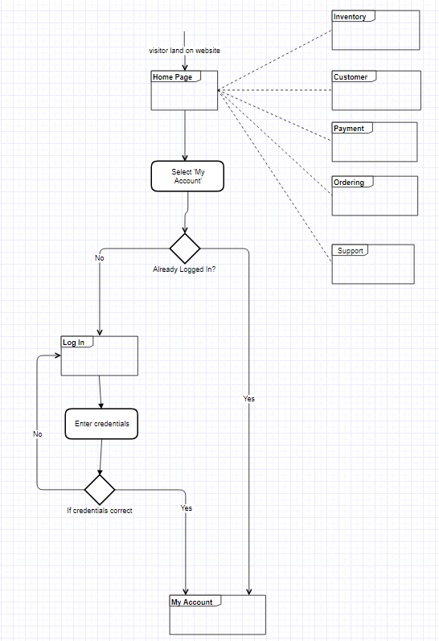

**Database Design**

The Design gives us a detailed data model of the database. This graphical representation contains all the logical and physical design choices along with the storage parameters that will be incorporated into the final design. This will in turn be used to generate the working database of the application.

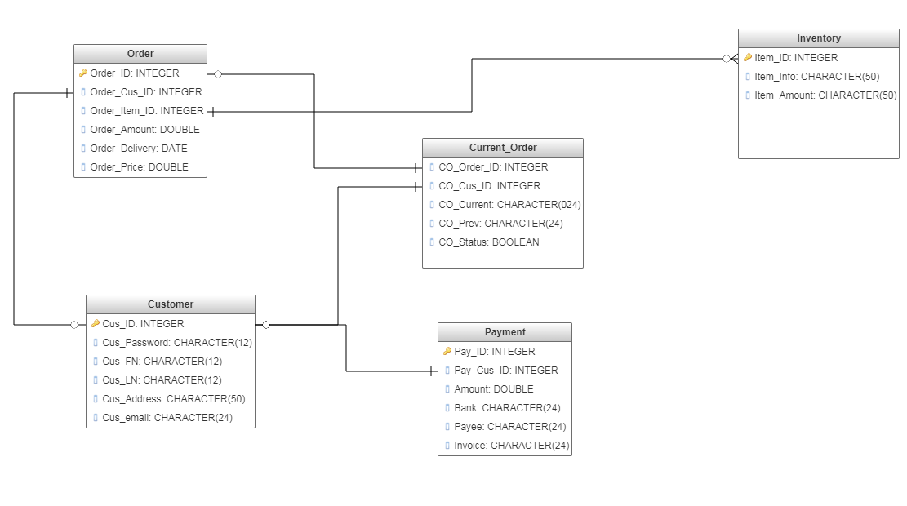

Interface Design

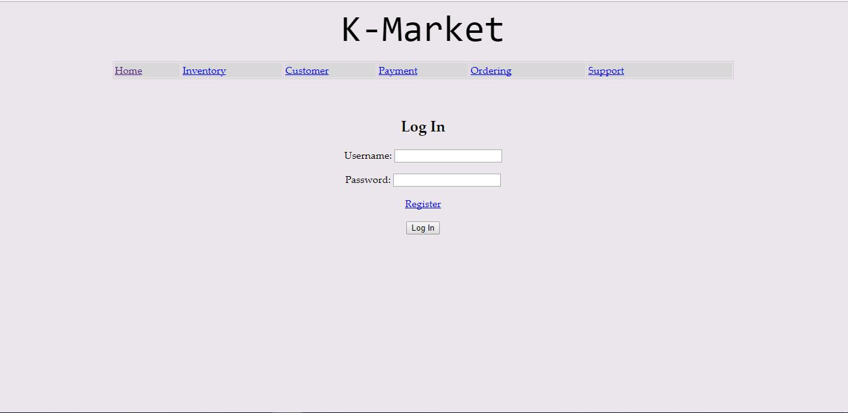

The above screencap shows us the login home page of our client website, where they will be able to enter their user credentials to login to their own personalized online storefront to manage orders and inventory.

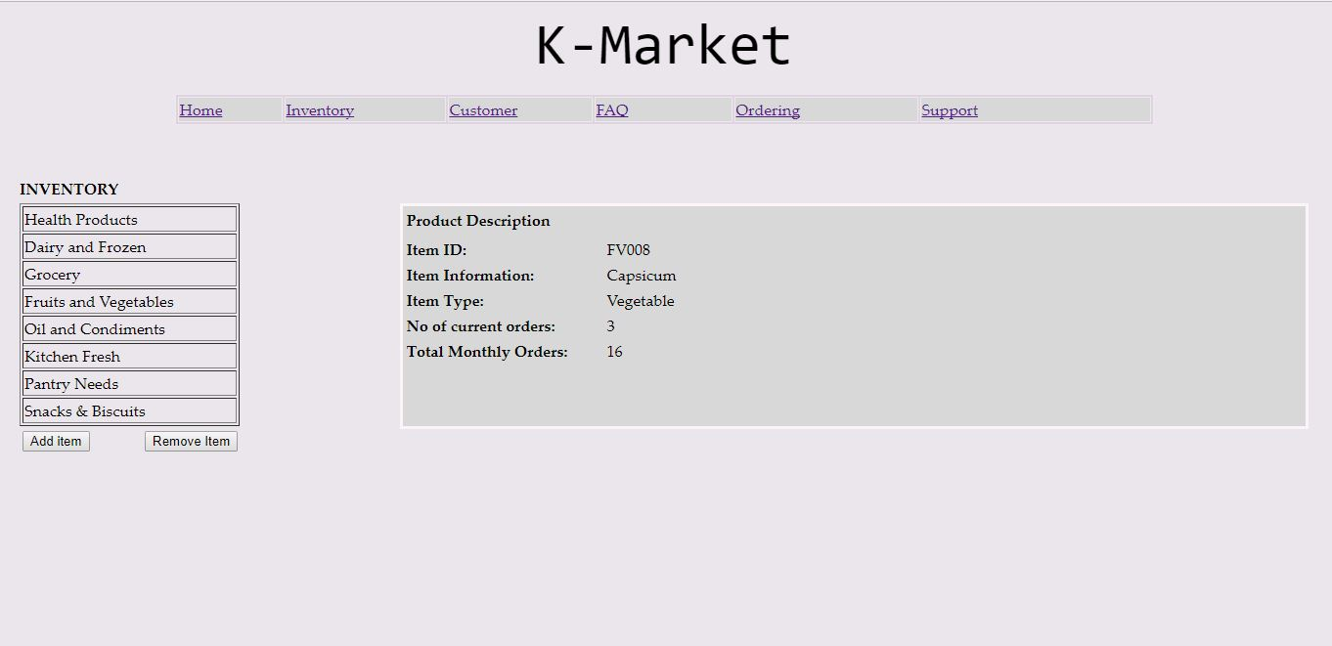

The above screencap shows us the inventory management screen of our website where our client will be able to manage their distribution service and grocery stock to set up delivery schedules.

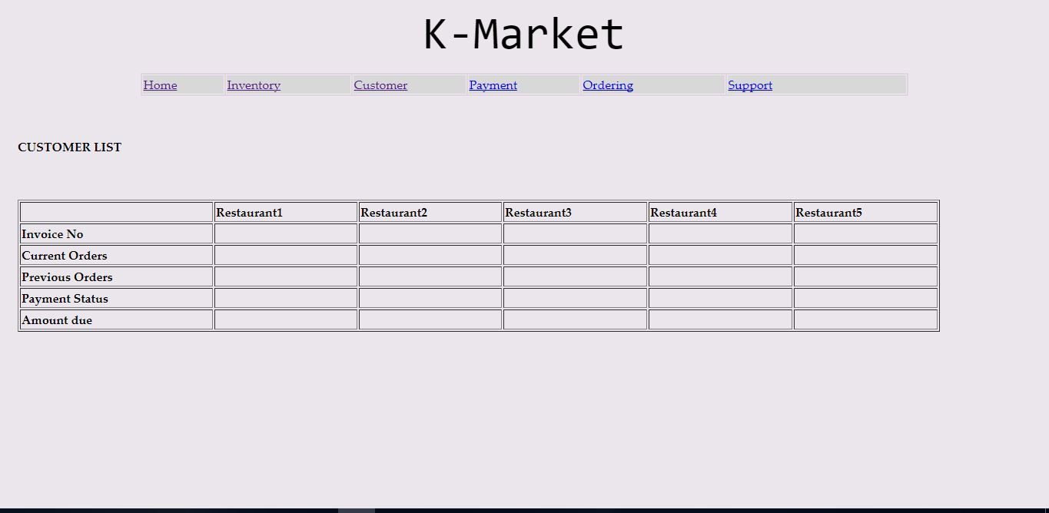

The above screencap lists all the end-user (restaurant) accounts that have registered with our client website that is stored in a database to be able to view their past history and current orders and interactions.

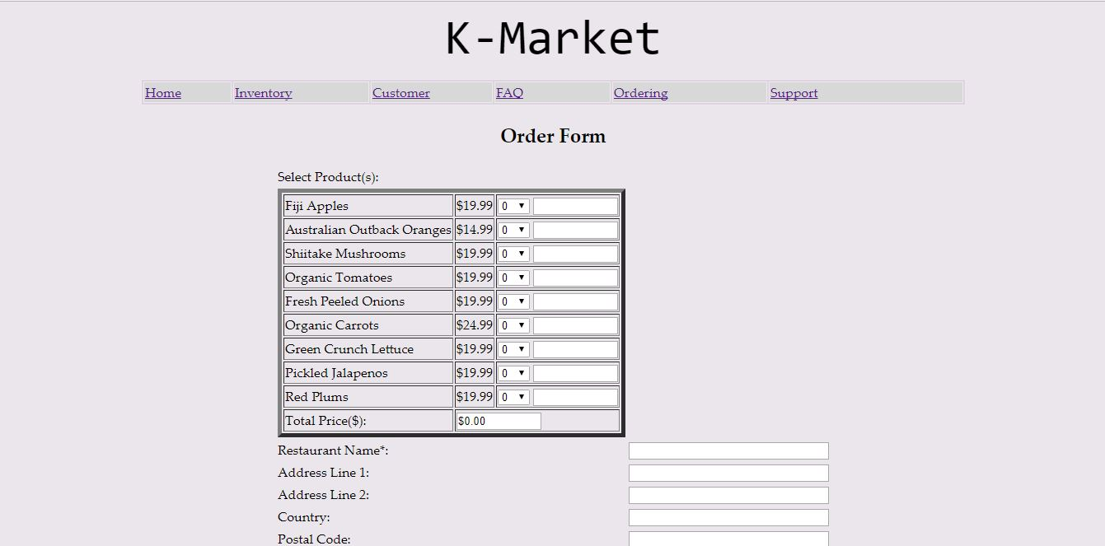

The above screencap displays the ordering page for restaurants that want to place online orders through our K-Market client and also the online payment portal after which their order will be received.

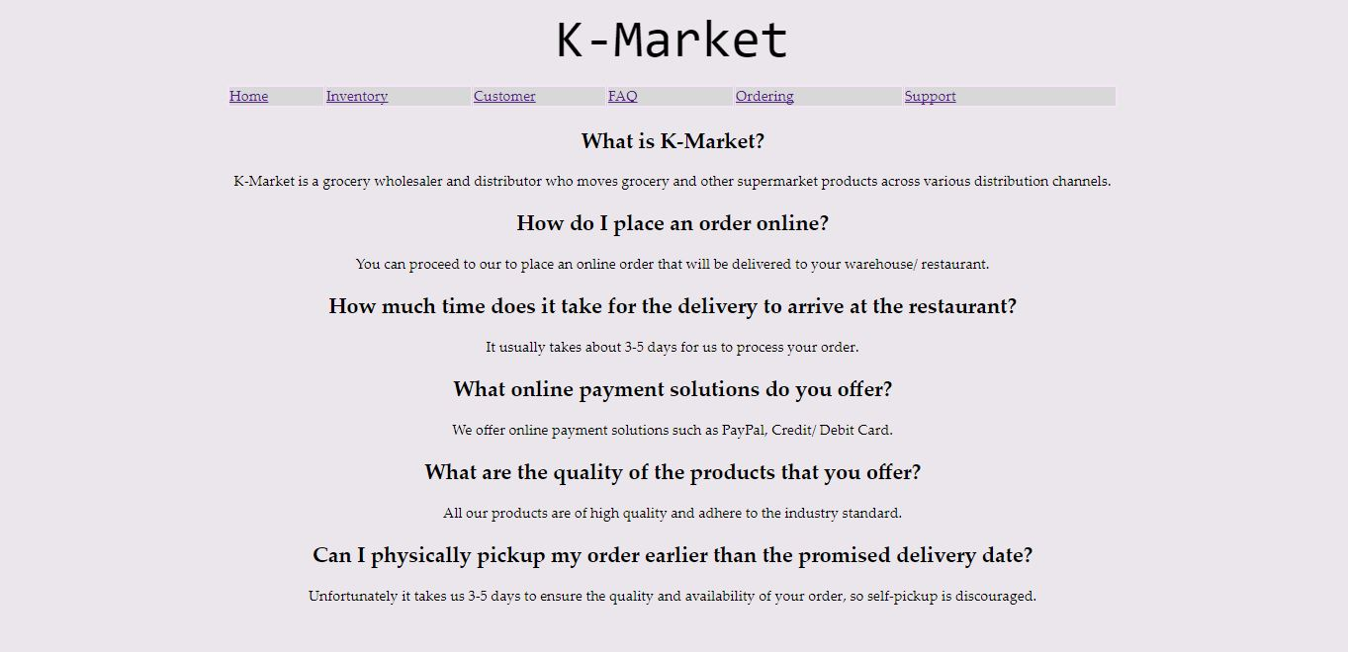

The above screencap shows us the F.A.Q page for end-users of K-Mart, this application is a streamlined and efficient wholesale portal, so the end-users are bound to have many queries which this page hopes to alleviate.

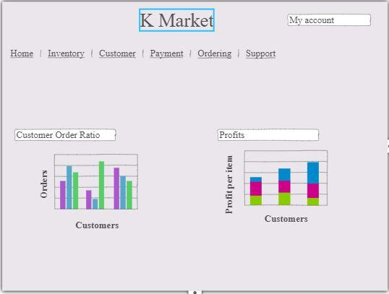

The above screencap displays the possible features such as graphical statistical analysis of the end-users who have registered on the website as well as monetary analysis. This page is being proposed as a possible design that can be implemented if a relational database was established.

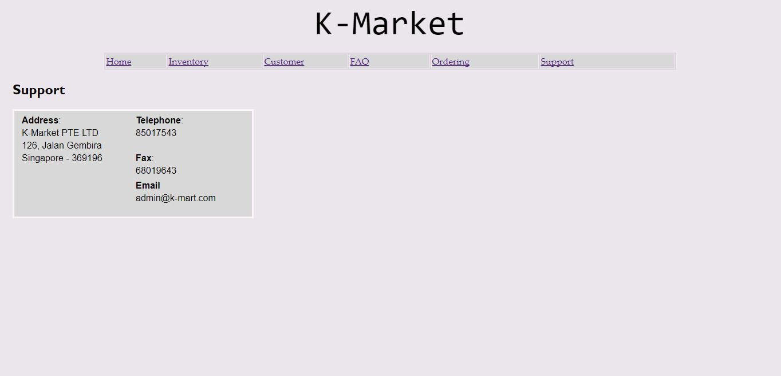

The above screencap displays our ‘contact us’ page where the end-user can find contact information and the location of K-Market’s physical outlet(s).

Github Repository Link:

<https://github.com/myth002/CP3407_A1> (Private repository)

Our project utilised the Github as a distributed control mechanism to have simultaneous access to all the files and updates. Each member of the group can instantly share their files and updates to the existing repository in order to create a continuous workflow to the project. We collaborated our work amongst ourselves along with our client, Mr Kummeng Lum, to constantly integrate our design with his requirements. We chose Github as a sharing mechanism because of it enhanced security and ease of management.

Teamwork details:

**Member details:**

|  |  |
| --- | --- |
| **Name** | **Contribution** |
| Anumolu Sandeep Prasad | Documentation and Web GUI, along with handling the JQuery to make the website operational and functioning. |
| Udaya Bhaskar Reddy Malkannagari | Documentation and Web GUI, setting up the basic template for the final design. Monitoring progress of individual group members. |
| Fadni Harisyam | Documentation and handling the research to provide accurate estimates in generating a profitable revenue stream |